Q1)
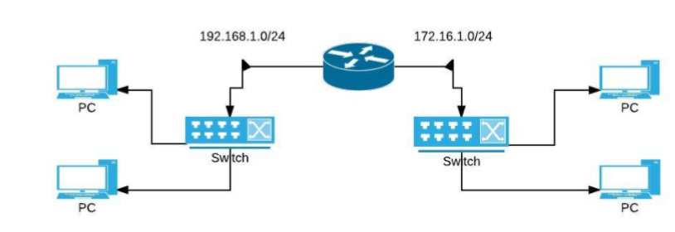

As shown in the network topology above configure the Router R1 and Desktop PC’s on different subnets. At the end of the setup, the working network should be able to send and receive traffic to/from any computer.
- Configure Hostname, IP Address and Subnet Mask for each Gigabit Ethernet Interface connected to both switches.
- Configure IP Address, Subnet Mask and Default Gateway for PC’s.

Q2)
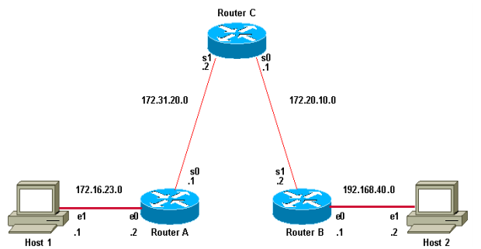
Create the above shown network topology using packet tracer.

